K 3(2)
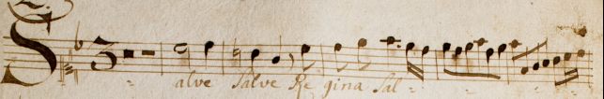

K 20
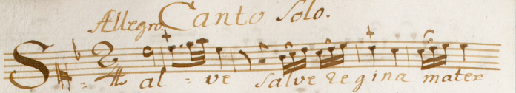

K 22
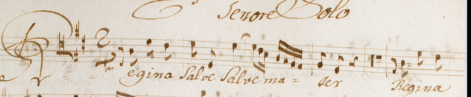

K 23
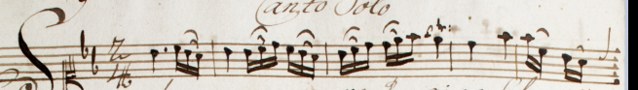

K 25
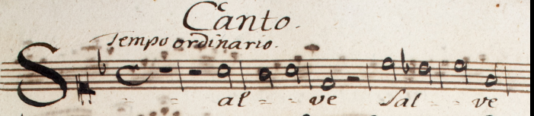

K 26
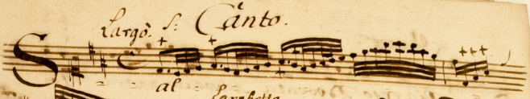

K 29
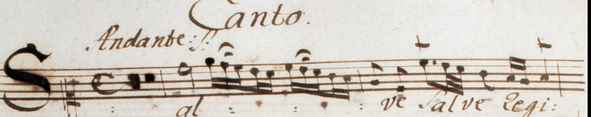

K 30
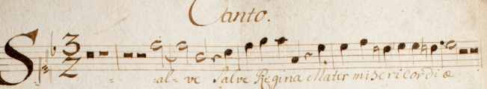

M 8 & 12
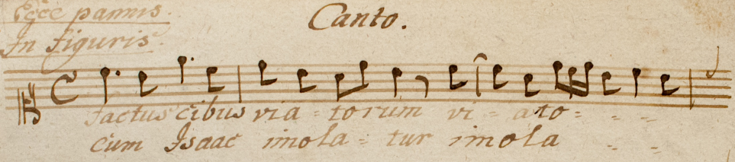

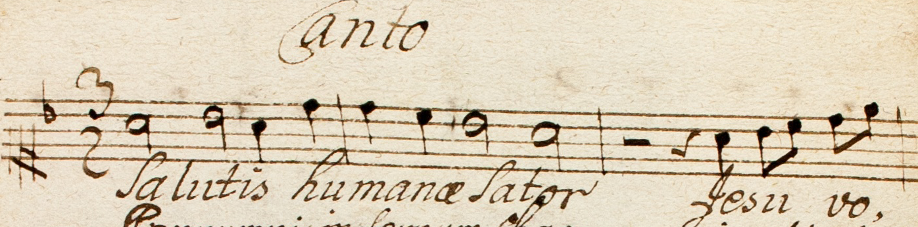
M 10
M 42 → H-Bn 210/6 with different text
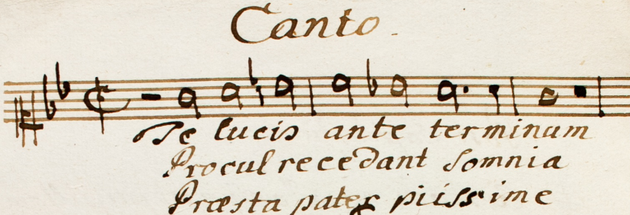

A-KN 118/14
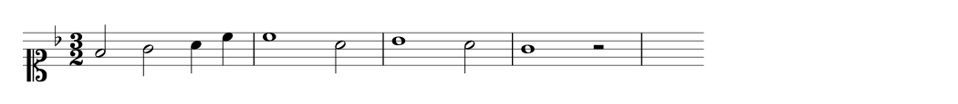
Jesu Redemptor omnium

A-KN 130 [046]
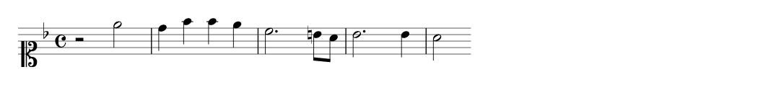
Quibus patris clementiam

